Chapter 14: Work, Power, & Machines Vocabulary Review
MATCHING Place the word and letter in the blank next to the correct definition.

a. | work | n. | output distance
b. | power | o. | work output
c. | joule (J) | p. | input force
d. | watt (W) | q. | work input
e. | machine | r. | work output
f. | lever | s. | output force
g. | fulcrum | t. | mechanical advantage (MA)
h. | input arm | u. | ideal mechanical advantage (IMA)
i. | output arm | v. | efficiency
j. | wheel & axle | w. | screw
k. | inclined plane | x. | pulley
l. | wedge | y. | compound machine
m. | input distance | z. | friction

Letter | Word | Definition
1 |  | the product of distance and the force in the direction an object moves
2 |  | the force exerted by a machine
3 |  | the SI unit for work
4 |  | the mechanical advantage of a machine in the absence of friction
5 |  | a force that opposes the motion of objects that touch as they move past each other
6 |  | the force exerted on a machine
7 |  | the work done by a machine as the output force acts through the output distance
8 |  | the fixed point a lever rotates around
9 |  | the percentage of the work input that becomes work output in a machine
10 |  | a combination of two or more simple machines that operate together
11 |  | The distance between the fulcrum in a lever and the input force
12 |  | a device that changes a force and makes work easier
13 |  | the number of times that a machine increases an input force
14 |  | the distance through which the input forces acts in a machine
15 |  | the distance an output force acts through in a machine
16 |  | a slanted surface along which force moves an object to a different elevation
17 |  | an inclined plane wrapped around a cylinder

18 |  | the work done by a machine as the output force acts through the output distance
19 |  | a simple machine that consists of two rigidly attached disks or cylinders, each one with a different radius
20 |  | a rigid bar that is free to move around a fixed point
21 |  | a V-shaped object whose sides are two inclined planes sloped toward each other
22 |  | Th the SI unit for power, equal to one joule per second
23 |  | the work done on a machine as the input force acts through the input distance
24 |  | the rate of doing work
25 |  | a simple machine that consists of a rope that fits into a groove in a wheel
26 |  | the distance between the fulcrum in a lever and the output force

Directions: In the table below, identify the six (6) simple machines and give an example of each. Do NOT use the picture(s) provided as your examples.
27______________________    Example: ___________________ | 28______________________  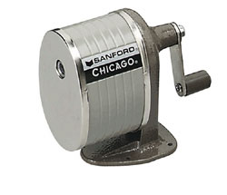  Example: ___________________ | 28______________________  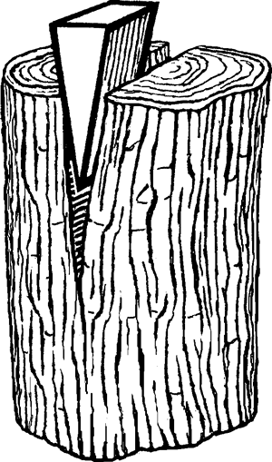  Example: ___________________
30______________________  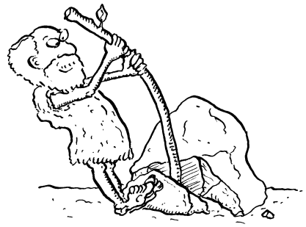  Example: ___________________ | 31______________________  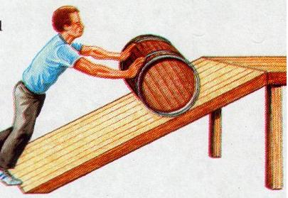  Example: ___________________ | 32______________________  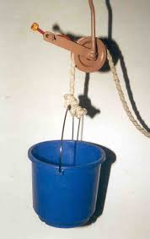  Example: ___________________

